
Muhammad Umer Ahmed
IU05-0125-0092
LAB 10 (File Allocation Strategies)

Objective: Write C programs to simulate file allocation strategies and clearly display how file data blocks are allocated on disk.

QUESTION NO: 01
Sequential File Allocation
Write a C program to simulate Sequential File Allocation.
Requirements:
- Ask the user to enter the number of files.
- For each file, input the file name, starting block number, and number of blocks required.
- Ask the user to enter a file name to search.
- If the file exists, display the file name, starting block, number of blocks, and all blocks occupied by the file.
- If the file does not exist, display "File Not Found". • The blocks of a file must be consecutive.
Example:
File Name: Student
Starting Block: 50
Number of Blocks: 5

Blocks Occupied:
50 51 52 53 54

Concept: In sequential/contiguous allocation, a file occupies consecutive disk blocks. If the starting block is 50 and 5 blocks are required, the occupied blocks are 50, 51, 52, 53 and 54.
CODE:
#include <stdio.h>
#include <string.h>

#define MAX_FILES 50
#define NAME_LEN 50

// Structure to represent a file
struct File {
char name[NAME_LEN];
int start_block;
int num_blocks;
};

int main() {
struct File files[MAX_FILES];
int num_files;
char search_name[NAME_LEN];
int found = 0;

// 1. Input total number of files
printf("Enter the number of files: ");
if (scanf("%d", &num_files) != 1 || num_files <= 0) {
printf("Invalid number of files.\n");
return 1;
}

// 2. Input details for each file
for (int i = 0; i < num_files; i++) {
printf("\n--- File %d Details ---\n", i + 1);
printf("Enter File Name: ");
scanf("%s", files[i].name);

printf("Enter Starting Block Number: ");
scanf("%d", &files[i].start_block);

printf("Enter Number of Blocks Required: ");
scanf("%d", &files[i].num_blocks);
}

// 3. Search for a file
printf("\n-----------------------------------\n");
printf("Enter File Name to Search: ");
scanf("%s", search_name);

// 4. Process and Display Results
for (int i = 0; i < num_files; i++) {
if (strcmp(files[i].name, search_name) == 0) {
found = 1;
printf("\nFile Found!\n");
printf("File Name: %s\n", files[i].name);
printf("Starting Block: %d\n", files[i].start_block);
printf("Number of Blocks: %d\n", files[i].num_blocks);

// Display consecutive occupied blocks
printf("Blocks Occupied:\n");
for (int j = 0; j < files[i].num_blocks; j++) {
printf("%d ", files[i].start_block + j);
}
printf("\n");
break;
}
}

// 5. Handle File Not Found case
if (!found) {
printf("\nFile Not Found\n");
}

return 0;
}
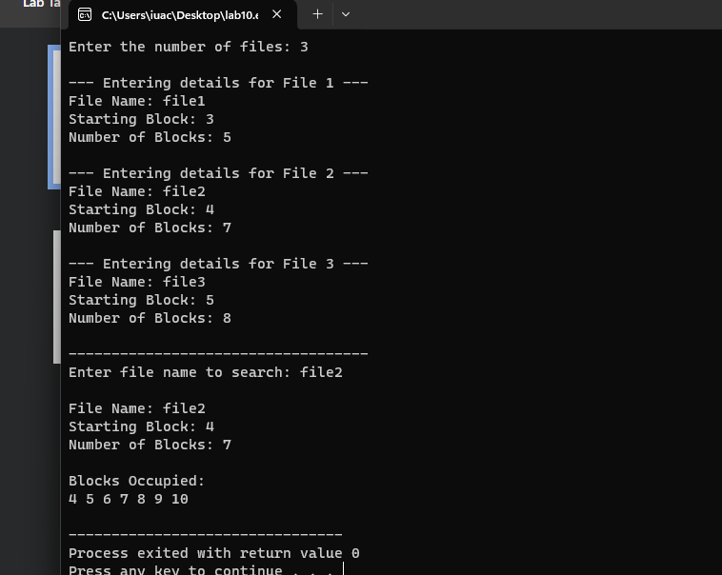

QUESTION NO: 02
Menu-Driven File Allocation Simulator
Write a menu-driven C program that simulates the following three file allocation strategies:
- 1. Sequential Allocation
- 2. Linked Allocation
- 3. Indexed Allocation
- 4. Exit

For the selected option, the program should:
- Ask the user to enter a file name.
- Ask the user to enter the number of blocks required.
- Take the required block information according to the selected allocation strategy.
- Display the blocks occupied by the file in a clear format.

A. Sequential Allocation
Ask for a starting block and number of blocks. Generate the remaining consecutive block numbers automatically.
Starting Block: 100
Number of Blocks: 4

Allocated:
100 → 101 → 102 → 103

B. Linked Allocation
Ask the user to enter scattered block numbers. Display them as a linked chain. The last block should point to NULL.
Blocks entered:
12 45 7 89

Allocated:
12 → 45 → 7 → 89 → NULL

C. Indexed Allocation
Ask the user to enter an index block and the data block numbers. Display the index block and the data blocks referenced by it.
Index Block: 20

Index Block 20
|
+----> 12
+----> 45 +----> 7
+----> 89

Important: The program must implement the allocation logic for all three strategies.
Do not simply print the entered values; clearly represent how the blocks are organized for each strategy.
CODE:
#include <stdio.h>
#include <stdlib.h>

#define MAX_BLOCKS 100

// Function prototypes
void sequentialAllocation();
void linkedAllocation();
void indexedAllocation();

int main() {
int choice;

while (1) {
printf("\n====================================\n");
printf(" FILE ALLOCATION SIMULATOR \n");
printf("====================================\n");
printf("1. Sequential Allocation\n");
printf("2. Linked Allocation\n");
printf("3. Indexed Allocation\n");
printf("4. Exit\n");
printf("------------------------------------\n");
printf("Enter your choice (1-4): ");
if (scanf("%d", &choice) != 1) {
printf("Invalid input. Exiting.\n");
break;
}

switch (choice) {
case 1:
sequentialAllocation();
break;
case 2:
linkedAllocation();
break;
case 3:
indexedAllocation();
break;
case 4:
printf("\nExiting program...\n");
exit(0);
default:
printf("\nInvalid choice! Please select between 1 and 4.\n");
}
}

return 0;
}

// 1. Sequential (Contiguous) File Allocation Strategy
void sequentialAllocation() {
char filename[50];
int start_block, num_blocks;

printf("\n--- SEQUENTIAL FILE ALLOCATION ---\n");
printf("Enter File Name: ");
scanf("%s", filename);

printf("Enter Starting Block: ");
scanf("%d", &start_block);

printf("Enter Number of Blocks: ");
scanf("%d", &num_blocks);

if (num_blocks <= 0) {
printf("Number of blocks must be greater than 0.\n");
return;
}

printf("\nFile: %s\n", filename);
printf("Allocated: \n");
for (int i = 0; i < num_blocks; i++) {
printf("%d", start_block + i);
if (i < num_blocks - 1) {
printf(" -> ");
}
}
printf("\n");
}

// 2. Linked File Allocation Strategy
void linkedAllocation() {
char filename[50];
int num_blocks;
int blocks[MAX_BLOCKS];

printf("\n--- LINKED FILE ALLOCATION ---\n");
printf("Enter File Name: ");
scanf("%s", filename);

printf("Enter Number of Blocks Required: ");
scanf("%d", &num_blocks);

if (num_blocks <= 0 || num_blocks > MAX_BLOCKS) {
printf("Invalid number of blocks.\n");
return;
}

printf("Enter %d scattered block numbers:\n", num_blocks);
for (int i = 0; i < num_blocks; i++) {
printf("Block %d: ", i + 1);
scanf("%d", &blocks[i]);
}

printf("\nFile: %s\n", filename);
printf("Allocated: \n");
for (int i = 0; i < num_blocks; i++) {
printf("%d -> ", blocks[i]);
}
printf("NULL\n");
}

// 3. Indexed File Allocation Strategy
void indexedAllocation() {
char filename[50];
int index_block, num_blocks;
int data_blocks[MAX_BLOCKS];

printf("\n--- INDEXED FILE ALLOCATION ---\n");
printf("Enter File Name: ");
scanf("%s", filename);

printf("Enter Index Block Number: ");
scanf("%d", &index_block);

printf("Enter Number of Data Blocks Required: ");
scanf("%d", &num_blocks);

if (num_blocks <= 0 || num_blocks > MAX_BLOCKS) {
printf("Invalid number of blocks.\n");
return;
}

printf("Enter %d data block numbers:\n", num_blocks);
for (int i = 0; i < num_blocks; i++) {
printf("Data Block %d: ", i + 1);
scanf("%d", &data_blocks[i]);
}

printf("\nFile: %s\n", filename);
printf("Index Block: %d\n", index_block);
printf(" |\n");
for (int i = 0; i < num_blocks; i++) {
printf(" +----> %d\n", data_blocks[i]);
}
}




